**Week 6 Summary of Key Concepts**

**Lecture**

In lecture this week, we saw amplitudes of states and Born’s rule for determining the probability of getting different measurement outcomes. We were introduced to the Z gate, multi-qubit circuits, and the CX gate, which are all crucial tools in quantum algorithms and protocols.

1. The **amplitude of a state** is the contribution it makes to a superposition. Mathematically, it is the number in front of a state.

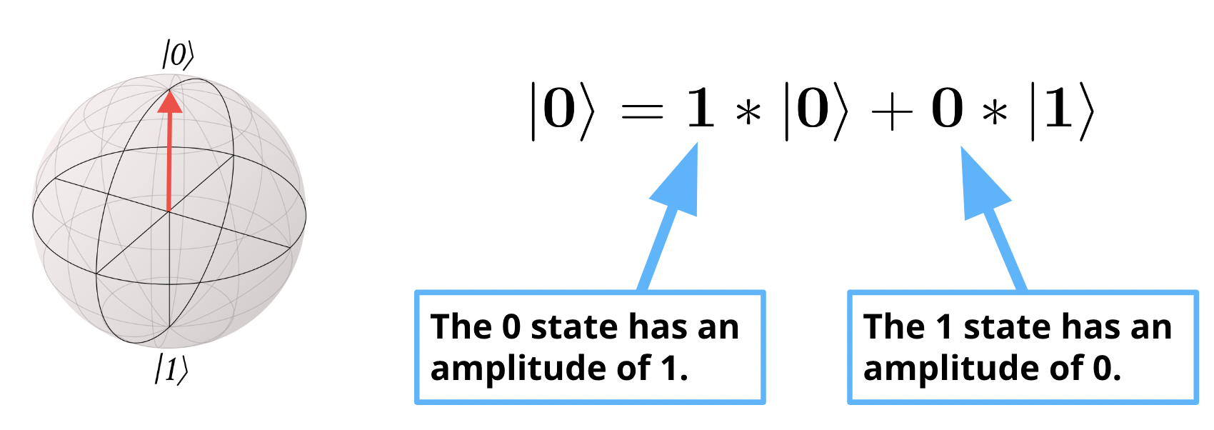

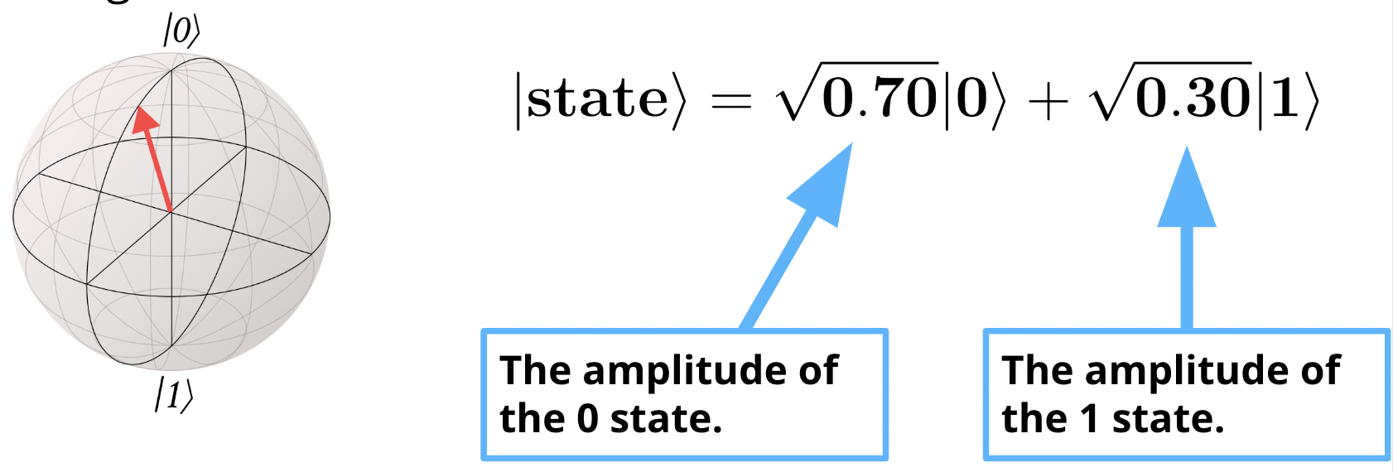

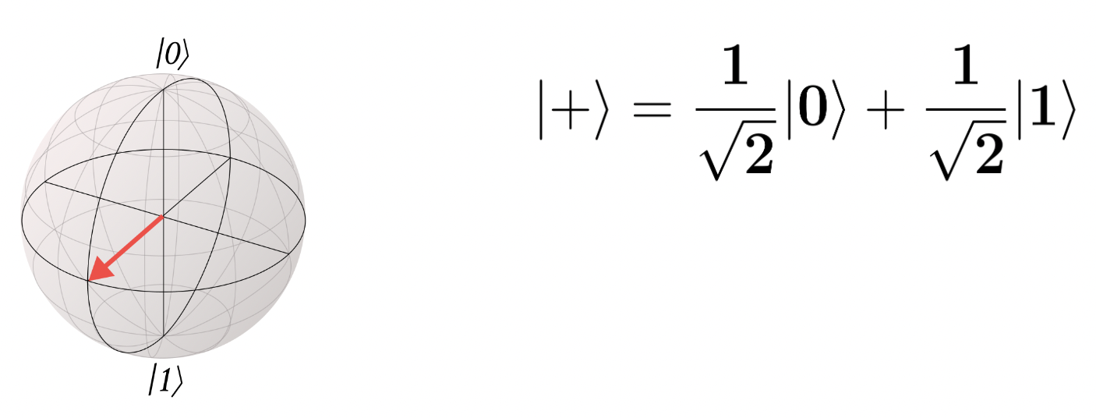

1. We can use **Born’s rule to determine the probability of measuring** 0 or 1 for any state!

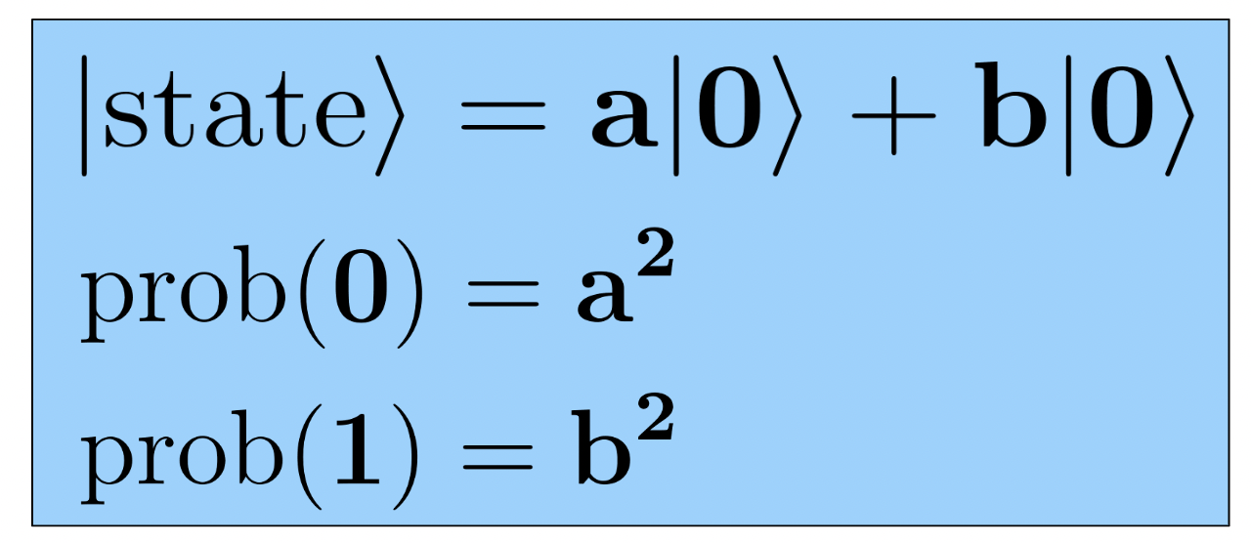

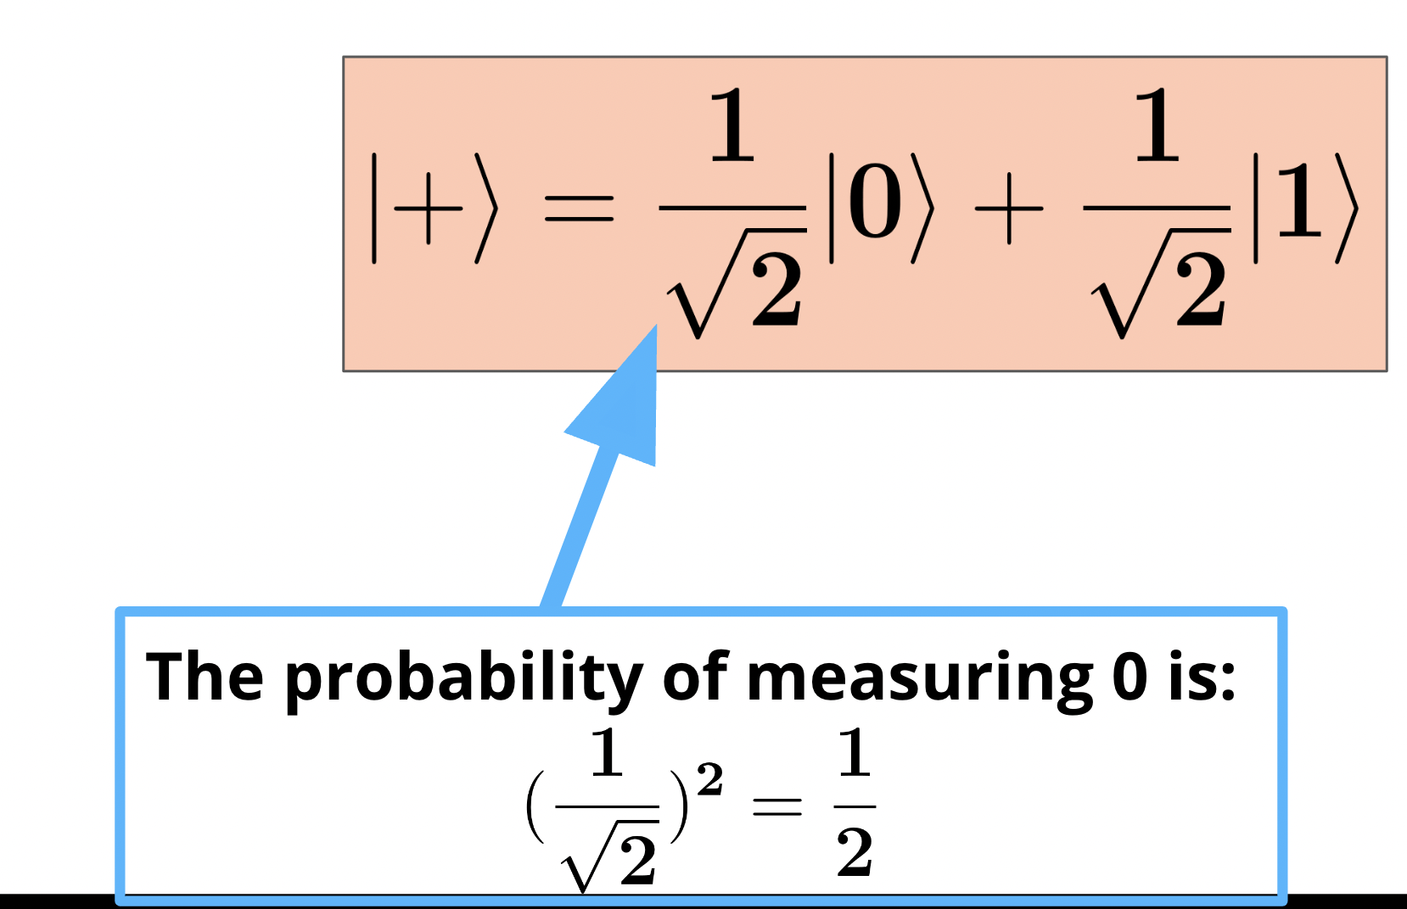

1. The **Z gate is a 180° rotation around the z-axis**.

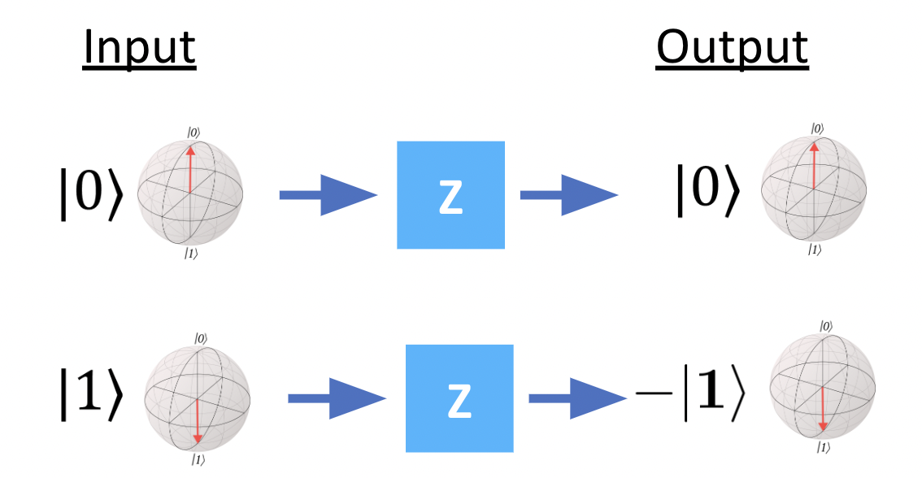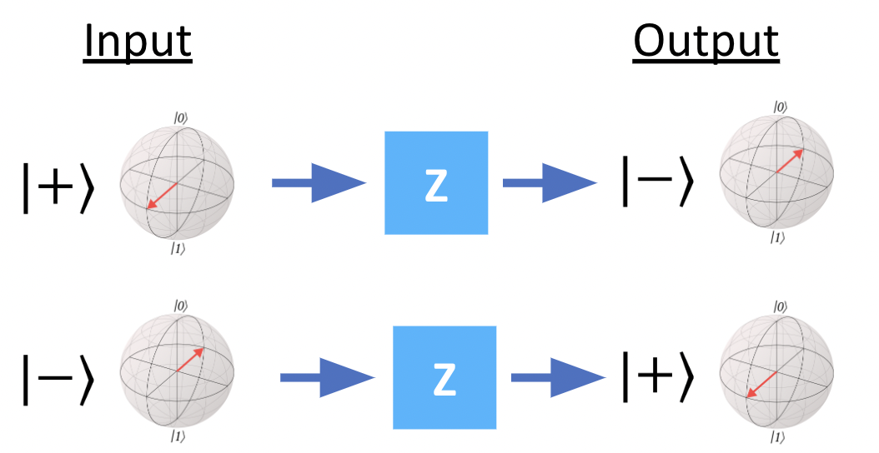

1. The **Controlled X (CX or CNOT) Gate** is a 2-qubit gate that follow these rules:
   1. The control qubit never changes.
   2. If the control qubit is 0, do nothing to the target qubit.
   3. If the control qubit is 1, apply an X to the target qubit.

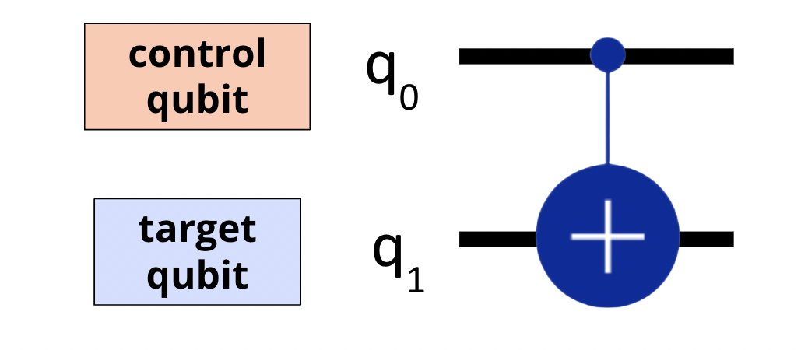

1. **Applying the** **CX gate to a superposition creates entanglement**:

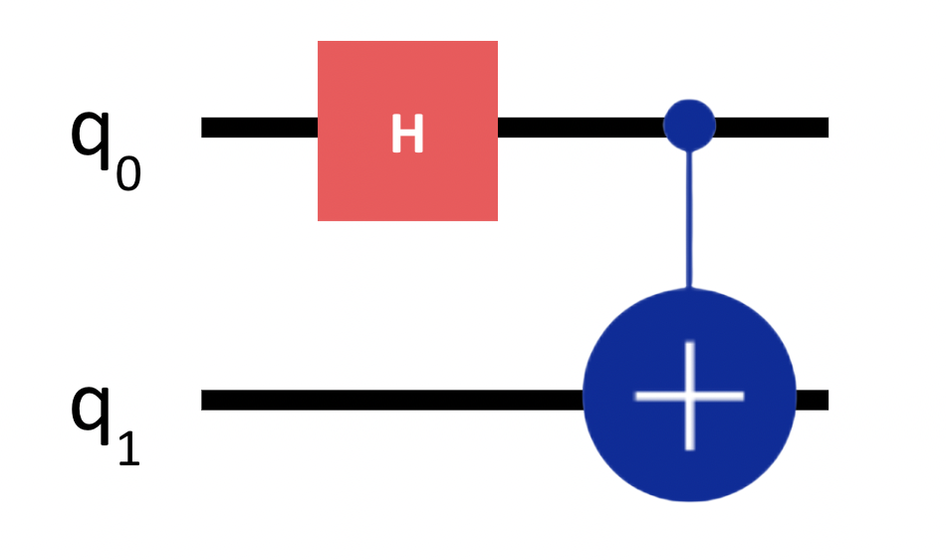

**Lab**

In lab this week, we learned how to implement the Z gate, multi-qubit circuits including measurements, and the CX gate. The major steps for creating and running circuits remain the same, but we modify the code at each step. The syntax for all the Qiskit code we have seen so far can be found in the handy cheat sheet below!

[Qiskit Cheat Sheet](https://docs.google.com/document/d/1co4RjY9BWPR_qJYbu8lJRNmCXMnBaOVOMH7a-avlMMU/edit?usp=sharing)